🛠 Using Special Access in D2L Quiz
Provide individual students with custom settings for quizzes — including extended time, alternate dates, or extra attempts — without affecting the rest of the class.

💡 What is Special Access?
Special Access allows instructors to:
✅ Grant additional time
✅ Change start/end dates for individual students
✅ Allow extra attempts
✅ Re-open a quiz for a single student
Perfect for accommodations, make-up work, or incomplete grades.

🔓 How to Enable Special Access in a Quiz

1. Go to Your Course
Open the destination course in Brightspace.
Navigate to Activities > Quizzes and select the quiz you want to modify.

2. Open the Availability Panel
You’ll now see a panel titled Availability Dates & Conditions (replacing the old “Restrictions” tab).
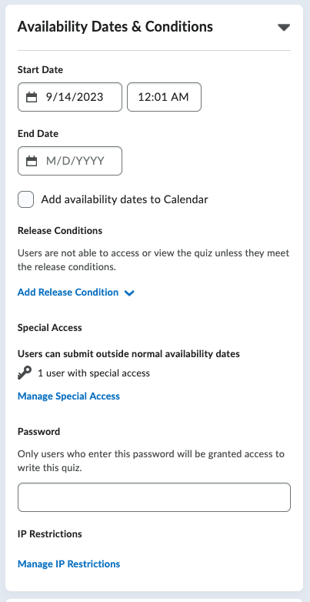
This section includes:
- 📅 Start/End Dates
- 🎯 Release Conditions
- 🛠 Special Access
- 🔑 Password Protection
- 🌐 IP Restrictions

Click Manage Special Access link to open the Special Access dialog box.

3. Enable Special Access
Choose one of two options:
- 🔘 Allow selected users special access to this quiz (recommended)
→ All students see original settings; only chosen students get exceptions.
- 🔘 Allow only users with special access to see this quiz
→ Use this for hidden makeup quizzes or alternative versions and only show to students you added to Special Access.
Click Add Users to Special Access.

4. Customize Special Access Settings
Here’s where you configure the exception:
- Availability Dates:
Adjust Start Date and End Date (for late or early access).
- Time Limit & Attempts:
✅ Grant extra time (e.g., time-and-a-half for accommodations).
✅ Add additional quiz attempts.

5. Select the Student(s)
At the bottom of the screen, check the box next to the student(s) receiving this access.
Click Save

6. Save Your Changes
You’ll be returned to the Special Access dialog box where you’ll see a table listing each Special Access entry.
Click Save and Close to finalize.

👀 Where Do Students See This?
Students with special access will:
- See the quiz appear on the adjusted date and time.
- Receive extended time limits or attempts automatically.

🔁 Need to Edit or Remove Special Access?
Back in the Special Access settings dialog box:
- Click the X icon to remove a student's special access.
- Or click their name to Pencil icon to edit the custom settings.

✅ Best Practices & Tips
✔️ Communicate with the Student – Let them know they have custom access.
✔️ Use "Add Users to Special Access" sparingly – It overrides default settings.
✔️ Double-check dates and times – Be sure the special access matches what you intended.
✔️ Consider Accessibility – Use this to meet students' documented accommodation needs.

